AI ASSISTED CODING
LAB ASSIGNMENT 7.5
T.SAI SATHWIK
2303A51221
BATCH – 04
Lab 7.5: Error Debugging with AI – Systematic Approaches to Finding and Fixing Bugs

Task 1: Mutable Default Argument – Function Bug
QUESTION
Analyze the given Python function where a mutable default argument causes unexpected behavior. Use AI assistance to fix the issue.
PROMPT
Identify the bug caused by using a mutable default argument in the function and modify the code so that the list is not shared between function calls.
CODE
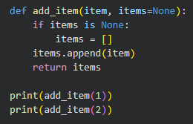
OUTPUT

EXPLANATION
In the original code, the default list was shared across multiple function calls, leading to unexpected results. By using None as the default value and creating a new list inside the function, each call gets its own independent list, avoiding shared state bugs.

Task 2: Floating-Point Precision Error
QUESTION
Analyze the given code where floating-point comparison fails due to precision issues. Use AI to correct it using tolerance.
PROMPT
Fix the floating-point comparison error by applying a tolerance-based comparison instead of direct equality.
CODE
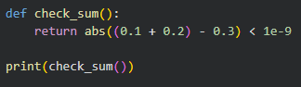
OUTPUT

EXPLANATION
Floating-point numbers cannot always be represented exactly in memory. Instead of direct comparison, a small tolerance value is used to check whether the numbers are close enough, ensuring reliable results.

Task 3: Recursion Error – Missing Base Case
QUESTION
Analyze the recursive function that runs infinitely due to a missing base case and fix it using AI guidance.
PROMPT
Add an appropriate base condition to stop infinite recursion in the function.
CODE
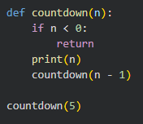
OUTPUT
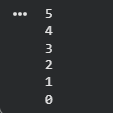
EXPLANATION
The original recursion lacked a stopping condition, causing infinite calls. Adding a base case ensures the function stops executing once the condition is met, preventing stack overflow errors.

Task 4: Dictionary Key Error
QUESTION
Analyze the code where accessing a non-existing dictionary key causes a runtime error and fix it.
PROMPT
Modify the code to safely access dictionary values using built-in methods or error handling.
CODE
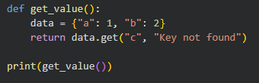
OUTPUT
EXPLANATION
Accessing a missing key using square brackets raises a KeyError. The .get() method safely returns a default value, preventing program crashes.

Task 5: Infinite Loop – Wrong Condition
QUESTION
Analyze the loop that never terminates due to a missing increment and correct it.
PROMPT
Fix the infinite loop by updating the loop variable correctly.
CODE
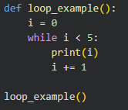
OUTPUT
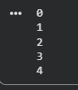
EXPLANATION
The loop variable was not updated in the original code, causing an infinite loop. Incrementing the variable ensures that the loop condition eventually becomes false.

Task 6: Unpacking Error – Wrong Variables
QUESTION
Analyze the tuple unpacking error where the number of variables does not match the tuple size.
PROMPT
Correct the unpacking error by adjusting variables appropriately.
CODE
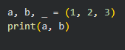
OUTPUT

EXPLANATION
Tuple unpacking requires matching the number of variables with values. The underscore _ is used to ignore extra values safely.

Task 7: Mixed Indentation – Tabs vs Spaces
QUESTION
Analyze the code where inconsistent indentation breaks execution and fix it.
PROMPT
Correct the indentation to follow consistent spacing rules.
CODE
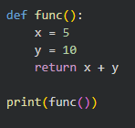
OUTPUT
EXPLANATION
Python is indentation-sensitive. Mixing tabs and spaces leads to syntax errors. Consistent indentation improves readability and prevents execution issues.

Task 8: Import Error – Wrong Module Usage
QUESTION
Analyze the code with an incorrect module import and fix it using AI assistance.
PROMPT
Correct the module name to ensure successful import and execution.
CODE
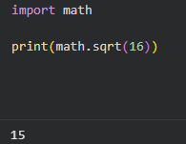
OUTPUT

EXPLANATION
The module name was incorrect in the original code. Importing the correct built-in module resolves the error and allows the function to work properly.

---THANKYOU---
2303A51221

